

Capstone Project Report
Report 3 – Software Requirement Specification

– Ho Chi Minh City, October 2025 –
Table of Contents
I. Record of Changes 3
II. Software Requirement Specification 4
1. Product Overview 4
2. User Requirements 5
2.1 Actors 5
2.2 Use Case 5
2.2.1 Use Case Diagram 5
2.2.2 Descriptions 7
3. Functional Requirements 12
3.1 System Functional Overview 12
3.1.1 Screens Flow 12
3.1.2 Screen Descriptions 13
3.1.3 Screen Authorization 13
3.1.4 Non-Screen Functions 13
3.1.5 Entity Relationship Diagram 14
4. Non-Functional Requirements 18
4.1 Security 18
4.2 Performance & Scalability 18
4.3 Interoperability & Compatibility 18
4.4 Availability & Reliability 18
5. Business Rules 18

I. Record of Changes
Date | A*  M, D | In charge | Change Description
28/10/2025 | A | Duong Minh Nhat | Adding document
10/11/2025 | M | Duong Minh Nhat | Updating document
01/12/2025 | M | Duong Minh Nhat | Reviewing and updating document
*A - Added M - Modified D - Deleted

II. Software Requirement Specification

1. Product Overview
The Learner Management and 3D Simulation System for Crane Training Center (LSSCTC) is an integrated software suite designed to address the high costs, significant safety risks, and logistical challenges of traditional crane operation training. The system provides a unified solution for both theoretical and simulated practical training.

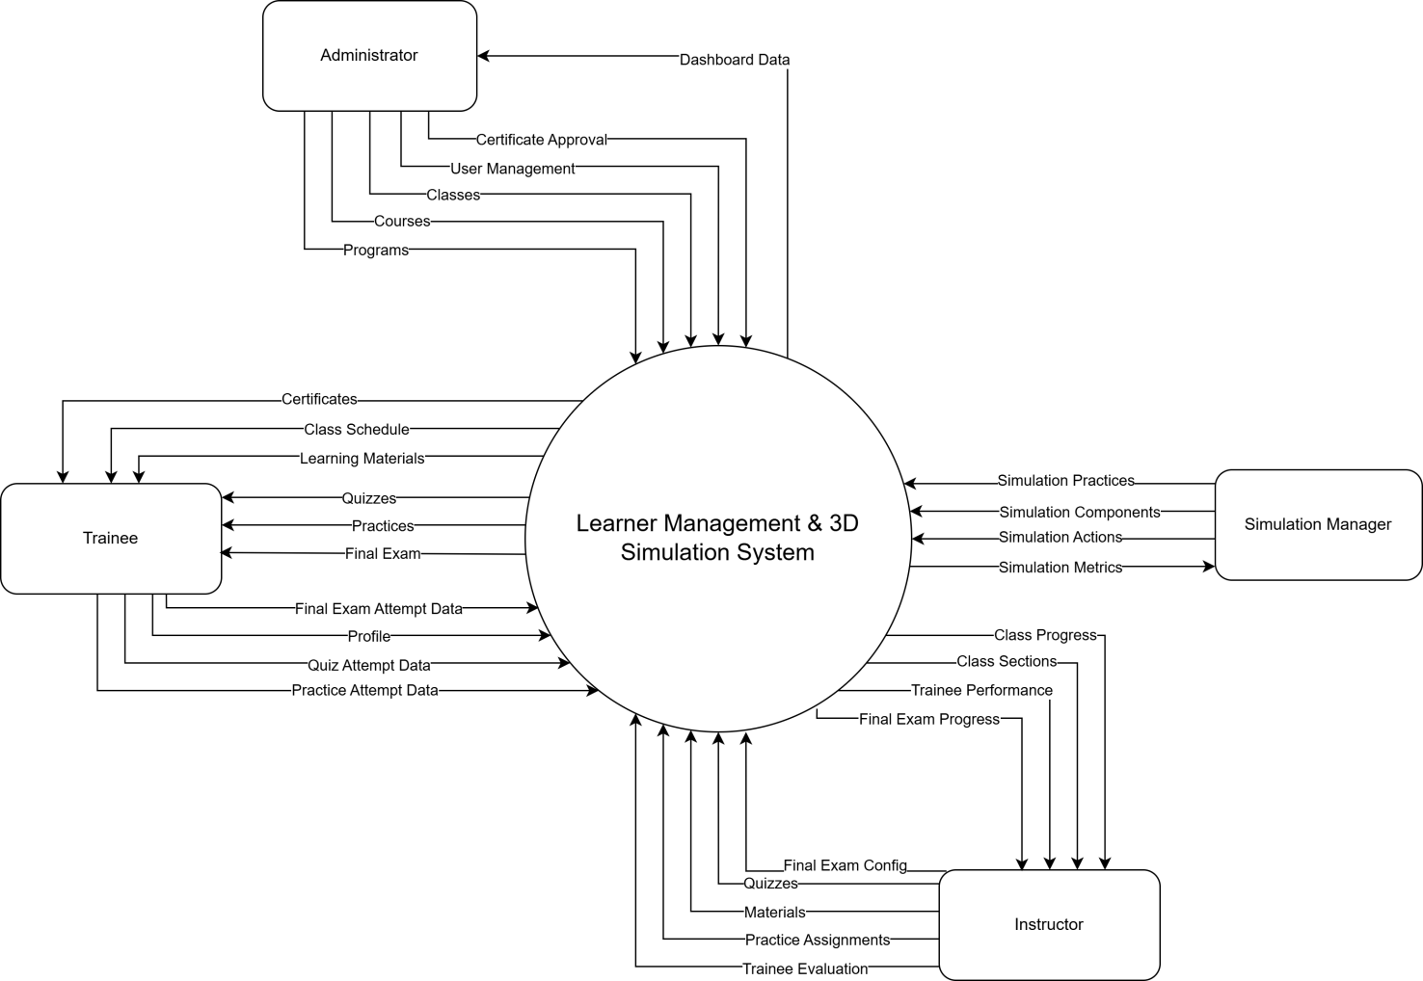

2. User Requirements

2.1 Actors
# | Actor | Description
1 | Administrator | The Administrator is the top-level user responsible for the overall system setup and user management. Using the web application, they manage all user accounts, create and organize the academic structure by managing programs, courses, and classes.
2 | Simulation Manager | The Simulation Manager is responsible for defining all aspects of the 3D simulation content. They manage the simulation practices, including simulation components, actions , and warnings.
3 | Instructor | The Instructor is responsible for managing the content and trainees within their assigned classes. Using the web application, they manage class members, organize class sections, and upload learning materials and quizzes. They also assign simulation practices to the class and are responsible for tracking trainee results, providing feedback , and confirming the final status for each trainee.
4 | Trainee | The Trainee is the primary learner in the system. They use the web application to manage their profile, enroll in classes, access learning materials, and complete theoretical quizzes. They also use the separate 3D simulation desktop application to log in and perform practical crane simulation exercises.

2.2 Use Case

2.2.1 Use Case Diagram

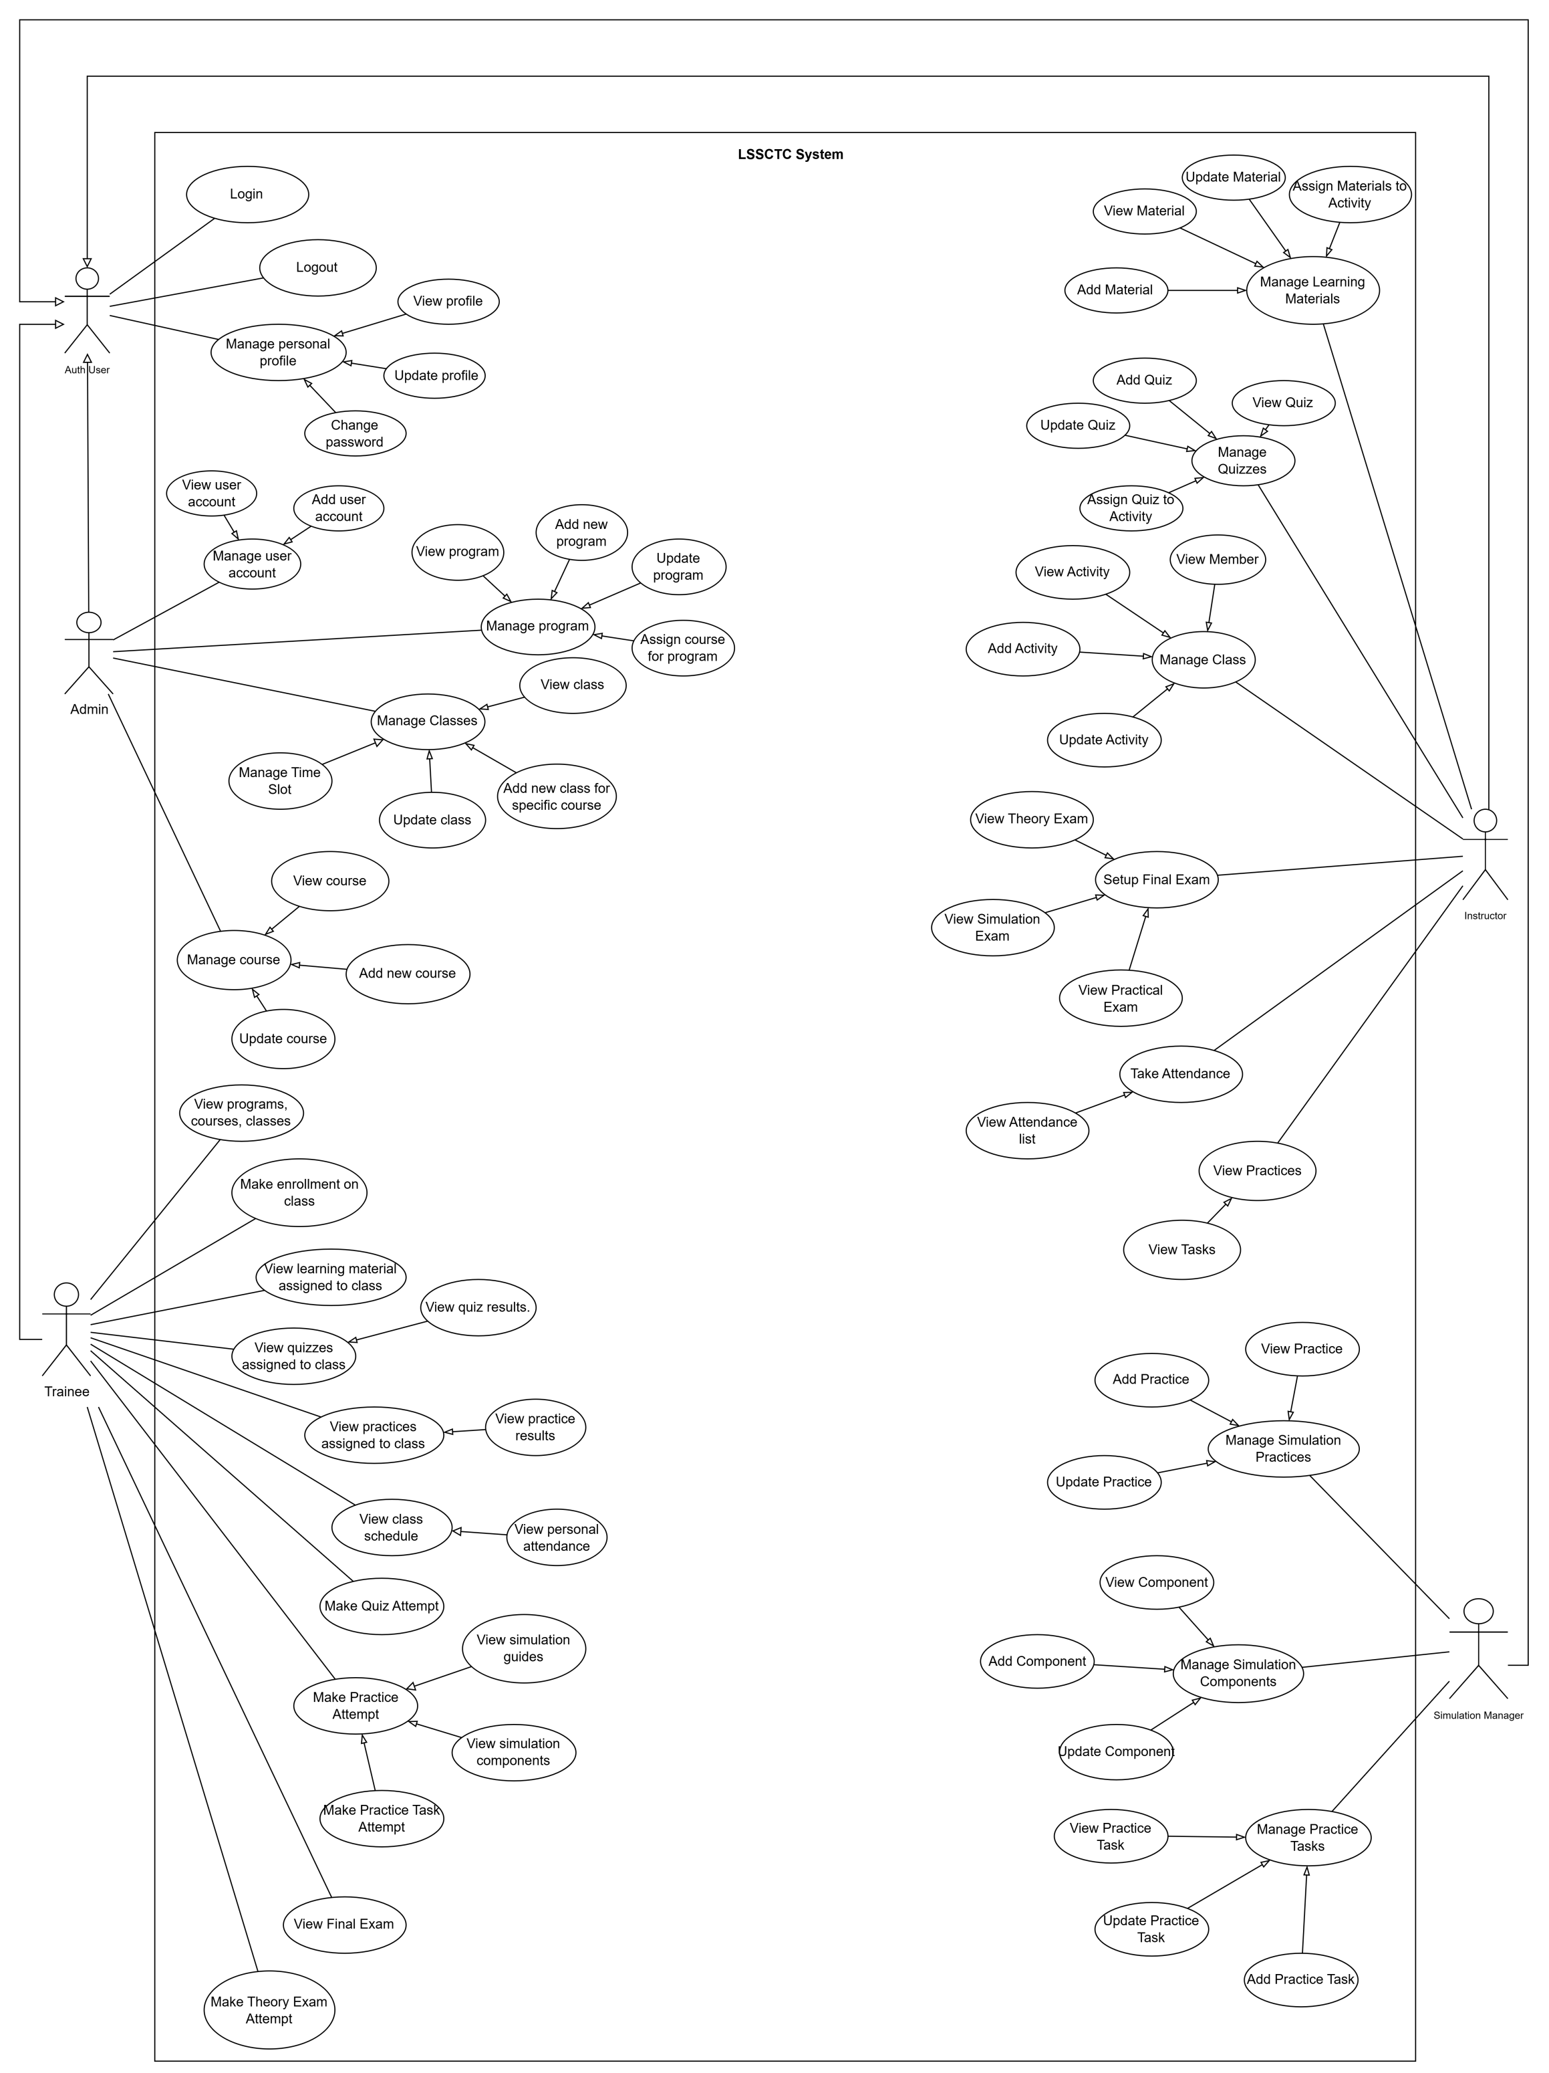

2.2.2 Descriptions
ID | Use Case | Actors | Use Case Description
UC-01 | Add Material | Instructor | This feature allows instructor add a new learning material (PDF, video, link) for teaching.
UC-02 | Update Material | Instructor | This feature allows instructor update an existing learning material’s info or file.
UC-03 | View Material | Instructor | This feature allows instructor view the list and details of learning materials.
UC-04 | Assign Materials to Section | Instructor | This feature allows instructor link selected materials to a section/partition for trainees to access.
UC-05 | Add Quiz | Instructor | This feature allows instructor create a new quiz with basic information.
UC-06 | Update Quiz | Instructor | This feature allows instructor edit a quiz’s information.
UC-07 | View Quiz | Instructor | This feature allows instructor view quizzes and their details.
UC-08 | Assign Quiz to Section | Instructor | This feature allows instructor attach a quiz to a specific section/partition for delivery.
UC-09 | Add Member | Instructor | This feature allows instructor add a trainee to the class roster.
UC-10 | View Member | Instructor | This feature allows instructor view trainee profiles and class membership.
UC-11 | Track Member Process | Instructor | This feature allows instructor track each trainee’s study progress and results.
UC-12 | View Section | Instructor | This feature allows instructor track each trainee’s study progress and results.
UC-13 | Add Section | Instructor | This feature allows instructor create a new section for the class.
UC-14 | Update Section | Instructor | This feature allows instructor edit section information.
UC-15 | Assign Practices to Section | Instructor | This feature allows instructor link practice activities to a section/partition.
UC-16 | View Practices | Instructor | This feature allows instructor view practice list and details in the class/section.
UC-17 | Confirm Pass/Fail Results | Instructor | This feature allows instructor view practice list and details in the class/section.
UC-18 | Add Practice | Instructor | This feature allows instructor create a new practice activity.
UC-19 | Update Practice | Instructor | This feature allows instructor edit an existing practice activity.
UC-20 | View Practices | Instructor | This feature allows instructor view details of a specific practice activity.
UC-21 | Add Component | Instructor | This feature allows instructor add a simulation component needed for practice.
UC-22 | Update Component | Instructor | This feature allows instructor update a simulation component’s information.
UC-23 | View Component | Instructor | This feature allows instructor view the list and details of simulation components.
UC-24 | Add Action | Instructor | This feature allows instructor add a simulation action/step used in practices.
UC-25 | Update Action | Instructor | This feature allows instructor update a simulation action/step.
UC-26 | View Action | Instructor | This feature allows instructor view the list and details of simulation actions.
UC-27 | Add Component | Simulation Manager | This feature allows the simulation manager to add a new simulation component to the system.
UC-28 | Update Component | Simulation Manager | This feature allows the simulation manager to edit or update existing simulation component information.
UC-29 | View Component | Simulation Manager | This feature allows the simulation manager to view the list and details of simulation components.
UC-30 | Add Action | Simulation Manager | This feature allows the simulation manager to add a new simulation action used in training practices.
UC-31 | Update Action | Simulation Manager | This feature allows the simulation manager to edit or update existing simulation actions.
UC-32 | View Action | Simulation Manager | This feature allows the simulation manager to view the list and details of simulation actions.
UC-33 | Add Slot | Simulation Manager | This feature allows the simulation manager to create a new simulation timeslot for scheduling practices.
UC-34 | Update Slot | Simulation Manager | This feature allows the simulation manager to update or reschedule an existing simulation timeslot.
UC-35 | View Slot | Simulation Manager | This feature allows the simulation manager to view all simulation timeslots and their details.
UC-36 | Assign Practice to Slot | Simulation Manager | This feature allows the simulation manager to assign a specific practice activity to a simulation timeslot.
UC-37 | Add Practice Step | Simulation Manager | This feature allows the simulation manager to define and add new steps for a practice scenario.
UC-38 | Update Practice Step | Simulation Manager | This feature allows the simulation manager to modify or reorder steps within a practice scenario.
UC-39 | View Practice Step | Simulation Manager | This feature allows the simulation manager to view practice steps assigned to each practice activity.
UC-40 | Add Warning | Simulation Manager | This feature allows the simulation manager to create new warning messages or alerts for simulation steps.
UC-41 | Update Warning | Simulation Manager | This feature allows the simulation manager to modify or remove existing simulation warnings.
UC-42 | View Warning | Simulation Manager | This feature allows the simulation manager to view all defined warnings and their details.
UC-43 | Make enrollment programs/courses/classes | Trainee | This feature allows trainee submit an enrollment request to a program, course, or class.
UC-44 | View programs, courses, classes | Trainee | This feature allows trainee view the catalog and details of available programs, courses, and classes.
UC-45 | Access learning material | Trainee | This feature allows trainee access learning materials provided for their study.
UC-46 | View learning material assigned to class section | Trainee | This feature allows trainee view materials specifically assigned to their class section.
UC-47 | Download material | Trainee | This feature allows trainee download learning files for offline use.
UC-48 | View quizzes assigned to class section | Trainee | This feature allows trainee see newly assigned quizzes for their section.
UC-49 | Make attempt quizzes | Trainee | This feature allows trainee start and submit a quiz attempt.
UC-50 | View recorded results | Trainee | This feature allows trainee view their quiz scores and attempt history.
UC-51 | View practices assigned to class section | Trainee | This feature allows trainee view the list of practices assigned to their section.
UC-52 | Select a practice to make a new attempt | Trainee | This feature allows trainee choose a practice and create a new attempt.
UC-53 | View list practices | Trainee | This feature allows trainee browse the practice list available to them.
UC-54 | Settings simulation guides | Trainee | This feature allows trainee configure guidance options and hints for simulation.
UC-55 | View simulation guides | Trainee | This feature allows trainee read the simulation guidance before or during practice.
UC-56 | View practice steps and step details | Trainee | This feature allows trainee review each step and its detailed instructions.
UC-57 | View simulation components | Trainee | This feature allows trainee view components used in the simulation scenario.
UC-58 | Perform simulation actions | Trainee | This feature allows trainee perform the required actions in the simulator.
UC-59 | View post-practice result | Trainee | This feature allows trainee see overall results after completing a practice.
UC-60 | View step result and warning message | Trainee | This feature allows trainee check each step’s result and any warning messages.
UC-61 | View user account | Admin | This feature allows admin view the list and details of user accounts in the system.
UC-62 | Add user account | Admin | This feature allows admin create a new user account and assign a role.
UC-63 | Deactivate user account | Admin | This feature allows admin deactivate or disable a user account.
UC-64 | Manage user account | Admin | This feature allows admin manage all user accounts, including creating, viewing, and deactivating users.
UC-65 | View program | Admin | This feature allows admin view the list and details of existing training programs.
UC-66 | Add new program | Admin | This feature allows admin create a new training program in the system.
UC-67 | Update program | Admin | This feature allows admin edit information of an existing training program.
UC-68 | Assign course for program | Admin | This feature allows admin assign specific courses to a training program.
UC-69 | Manage program | Admin | This feature allows admin manage all training programs, including viewing, updating, and course assignment.
UC-70 | View class | Admin | This feature allows admin view the list and details of all classes in the system.
UC-71 | Add new class for specific course | Admin | This feature allows admin create a new class linked to a selected course.
UC-72 | Update class | Admin | This feature allows admin modify class information such as schedule or instructor.
UC-73 | Manage classes | Admin | This feature allows admin manage all classes, including creating, updating, and viewing them.
UC-74 | View course | Admin | This feature allows admin view the list and details of all courses in the system.
UC-75 | Add new course | Admin | This feature allows admin create a new course record in the system.
UC-76 | Update course | Admin | This feature allows admin edit the details of an existing course.
UC-77 | Manage course | Admin | This feature allows admin manage all courses, including adding, updating, and viewing them.
UC-78 | View programs, courses, classes | Admin | This feature allows admin view an overview list of all programs, courses, and classes in the system.
UC-79 | Login | Auth User | This feature allows user login to the system by verifying their credentials and accessing authorized functions.
UC-80 | Logout | Auth User | This feature allows user logout from the system securely and end their session.
UC-81 | View profile | Auth User | This feature allows user view their personal profile information stored in the system.
UC-82 | Update profile | Auth User | This feature allows user edit and update their personal profile details.
UC-83 | Change password | Auth User | This feature allows user change their password for account security.
UC-84 | Manage personal profile | Auth User | This feature allows user manage their personal profile, including viewing, editing, and changing password.

3. Functional Requirements

3.1 System Functional Overview

3.1.1 Screens Flow

3.1.1.1 Admin Flow
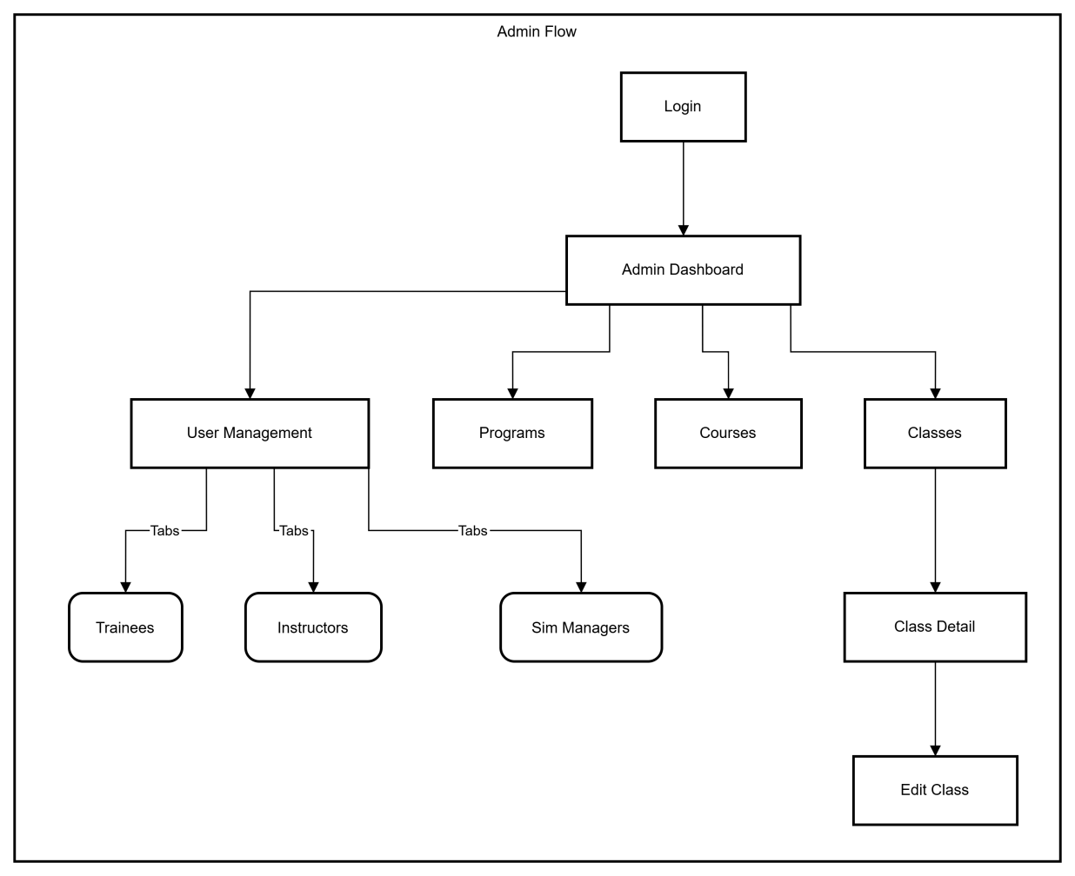

3.1.1.2 Trainee Flow
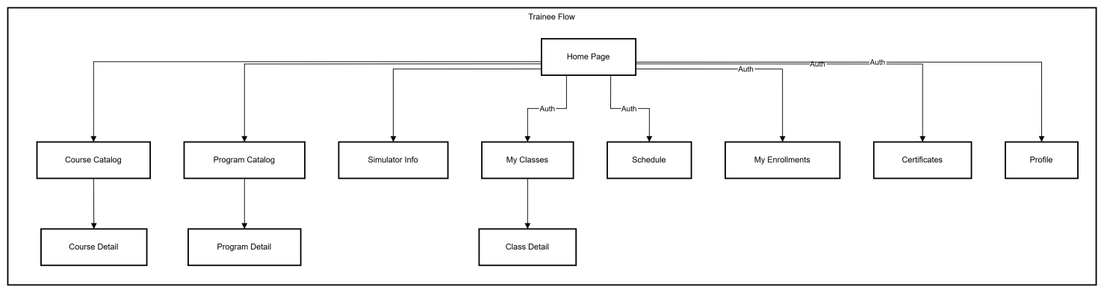

3.1.1.2 Instructor Flow
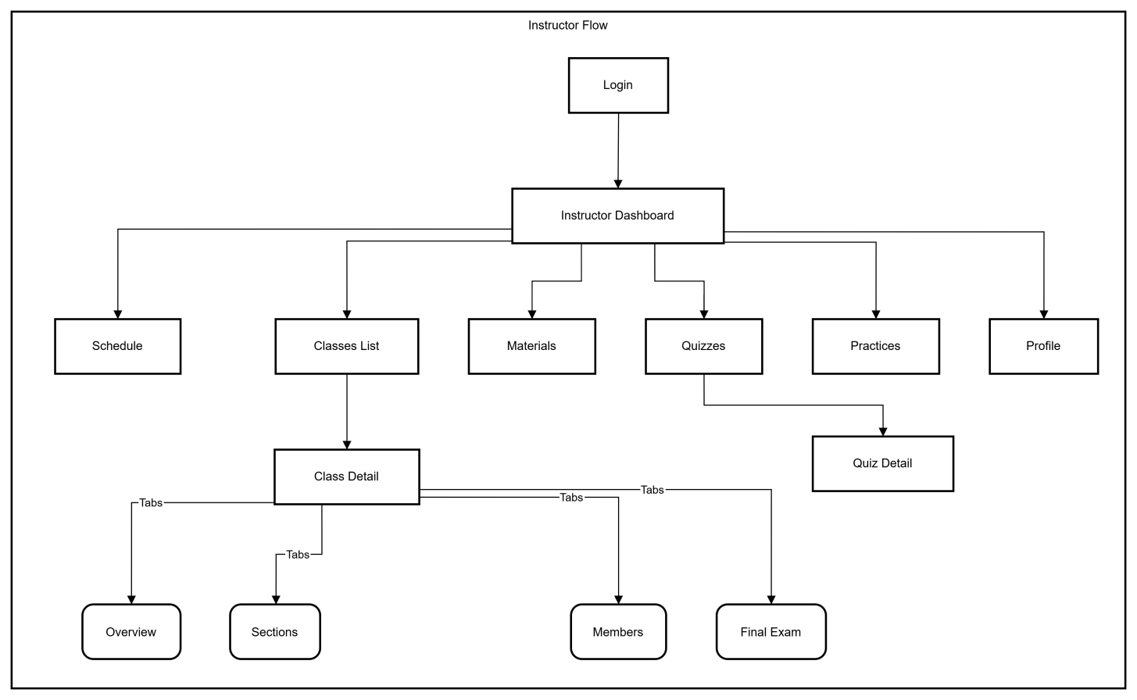

3.1.1.2 Simulation Manager Flow
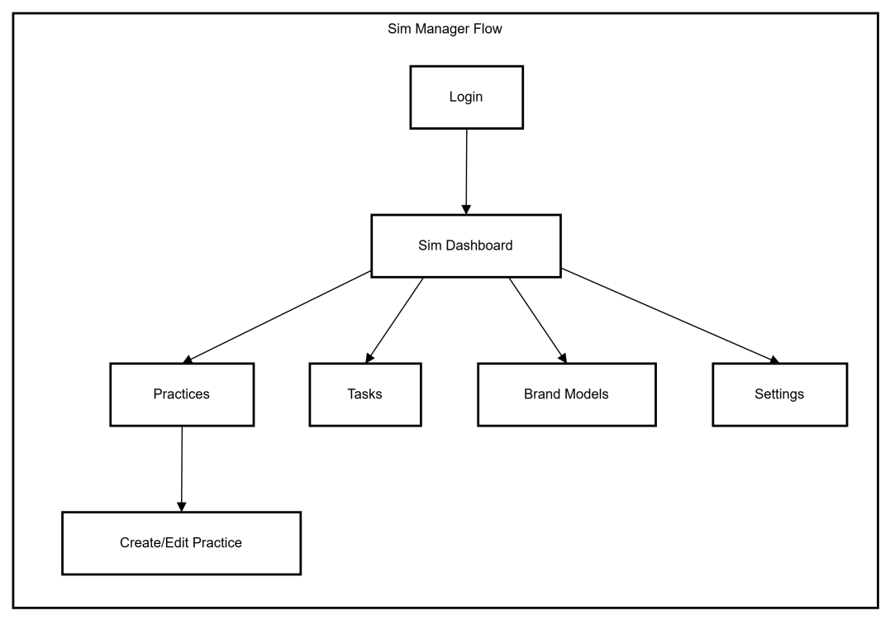

3.1.2 Screen Descriptions
[Provide the descriptions for the screens in the Screens Flow above]
# | Feature | Screen | Description
1 | Dashboard | Admin Dashboard | Overview of system statistics, user counts, and recent activities for Administrators.
2 | Dashboard | Instructor Dashboard | Overview of assigned classes, upcoming schedules, and student performance metrics.
3 | Dashboard | Sim Manager Dashboard | Status overview of active simulations, practice scenarios, and system health.
4 | User Management | User Lists | Interfaces to view and manage Trainees, Instructors, and Simulation Managers (tabs/tables).
5 | Program Management | Program List | Management of training programs, including creation and modification.
6 | Program Management | Program Catalog | Public view for trainees to browse available training programs.
7 | Course Management | Course List (Admin) | Administrative list of all courses to manage details and curriculum.
8 | Course Management | Course Catalog | Public view for trainees to browse and view details of specific courses.
9 | Class Management | Class Management (Admin) | List of classes for admins to create, edit, or view detailed class information.
10 | Class Management | Instructor Classes | List of classes assigned to the instructor for teaching.
11 | Class Management | My Classes (Trainee) | List of classes the trainee is currently enrolled in.
12 | Class Management | Class Detail | Detailed view of a specific class (Overview, Sections, Members, Schedule, Exams).
13 | Class Management | Schedule | Calendar view of teaching (Instructor) or learning (Trainee) sessions.
14 | Class Management | Quizzes | Management of quizzes, including creation and editing questions (Instructor).
15 | Class Management | Final Exam | Management and grading of final exams for a class.
16 | Simulation | Practices Management | Creation and configuration of simulation practice scenarios and steps.
17 | Simulation | Brand Models | Configuration of brand models used within simulations.
18 | Class Management | Materials | Management of learning materials and resources for courses.
19 | User Management | User Profile | View and edit personal account information.

3.1.3 Screen Authorization
Screen | Admin | Instructor | Trainee | Sim Manager
Admin Dashboard | X
Manage Users (Trainees, Instructors, etc.) | X
Manage Programs & Courses (Admin) | X
Manage Classes (Admin) | X
Instructor Dashboard |  | X
Instructor Schedule |  | X
Teaching Classes (List & Detail) |  | X
Class Attendance & Grading |  | X
Content Management (Materials, Sections) |  | X
Assessment Management (Quizzes, Practices) |  | X
My Classes (Trainee) |  |  | X
My Enrollments |  |  | X
Trainee Schedule |  |  | X
Certificates |  |  | X
Sim Manager Dashboard |  |  |  | X
Manage Practices & Tasks |  |  |  | X
Manage Brand Models |  |  |  | X
Simulation Settings |  |  |  | X

3.1.4 Non-Screen Functions
# | Feature | System Function | Description
1 | Authentication | Token Interception & Injection | Automatically intercepts outgoing API requests to inject the JWT authentication token into the headers, ensuring secure communication with the backend.
2 | Security | Role-Based Access Control (RBAC) | Validates the current user's role against the allowedroles defined for each protected route. If the user lacks permission, it automatically redirects them to the login page or a forbidden page.
3 | State Management | Global Session Store | Maintains the user's active session state (including profile data, role, and avatar URL) across different pages without requiring repeated API calls, using a client-side store (Zustand).
4 | Localization | Dynamic Language Switching | Manages the application's locale settings, dynamically swapping text resources between English (en) and Vietnamese (vi) and persisting the preference without reloading the page.
5 | Data Persistence | Cookie Management | Handles the secure storage and retrieval of authentication tokens and user preferences in browser cookies, allowing sessions to persist across browser restarts.
6 | Utility | Time Slot Status Calculation | Automatically calculates the status of a schedule slot (e.g., "Present", "Past", "Future") based on the current system time compared to the slot's start and end times, used for rendering calendar interfaces.

3.1.5 Entity Relationship Diagram

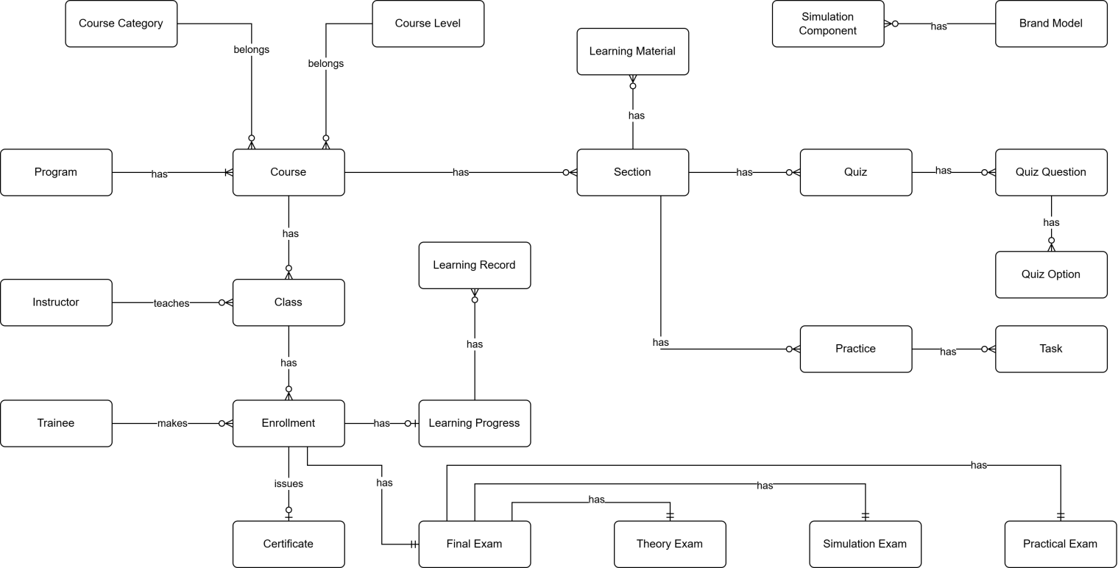

Entities Description
# | Entity | Description
1 | Course Category | Classification or categorization of courses by subject area or domain (e.g., Basic Crane Operations, Safety Procedures, Advanced Techniques). Provides organizational structure for grouping related courses. Each course belongs to one category.
2 | Course Level | Defines the difficulty or skill level of a course (e.g., Entry Level, Intermediate, Advanced). Used to establish learning progression paths and prerequisite requirements. Each course is assigned one level to indicate target trainee proficiency.
3 | Program | Comprehensive training program consisting of multiple courses designed to achieve specific certification or skill objectives. Programs define structured learning paths for trainees, combining courses in a logical sequence to build competencies for crane operator certification.
4 | Course | Individual training course representing a specific subject or skill area within the crane training curriculum. Contains course content structured into sections, can be assigned to multiple programs, and serves as the foundation for class creation. Belongs to one category and one level.
5 | Instructor | Teaching staff member responsible for delivering course instruction, managing class activities, creating learning materials and assessments, and evaluating trainee performance. Instructors are assigned to teach specific classes and provide guidance throughout the learning process.
6 | Class | Scheduled instance of a course with defined start/end dates, assigned instructor, and enrolled trainees. Represents the actual delivery of course content to a specific group of trainees. Classes are where learning activities, assessments, and instruction occur.
7 | Trainee | Student or learner enrolled in training programs to become certified crane operators. Trainees make enrollments in classes, access learning materials, complete quizzes and practices, take final exams, and track their learning progress toward certification.
8 | Enrollment | Record of a trainee's registration in a specific class. Creates the relationship between trainee and class, enabling access to course materials, activities, and assessments. Enrollment triggers creation of learning progress tracking and final exam records.
9 | Learning Material | Educational content resources such as videos, documents, presentations, or external links used to deliver course instruction. Materials are assigned to sections to provide trainees with reference and study resources. Can be reused across multiple sections.
10 | Section | Logical unit or module within a course syllabus representing a specific topic or learning objective. Sections organize course content into manageable chunks and contain learning materials, quizzes, and practices. Defines the structure and sequence of course curriculum.
11 | Quiz | Assessment tool containing multiple questions used to evaluate trainee understanding of theoretical concepts. Quizzes are assigned to sections, have defined pass criteria and time limits, and contribute to overall learning progress. Results are tracked through quiz attempts.
12 | Quiz Question | Individual question within a quiz presenting a problem or prompt for trainees to answer. Questions are assigned point values (contributing to total quiz score of 10 points) and can support single or multiple correct answers through associated quiz options.
13 | Quiz Option | Possible answer choice for a quiz question. Each option is marked as correct or incorrect and may have associated explanations. Multiple options per question enable various question types (multiple choice, select all that apply).
14 | Practice | Simulation-based training scenario performed in the 3D crane simulator environment. Practices consist of ordered tasks that trainees must complete to demonstrate hands-on skills. Assigned to sections as practical learning activities with defined difficulty levels and attempt limits.
15 | Task | Individual step or action within a simulation practice that trainees must perform correctly. Tasks define expected results for validation, and task completion is tracked during practice attempts. Tasks are reusable components across different practices.
16 | Simulation Component | 3D virtual representation of crane parts, controls, or environment objects used in simulation practices. Components are linked to brand models to represent real-world equipment and are referenced in tasks for interaction requirements.
17 | Brand Model | Specification of real crane equipment brands and models being simulated in the training system. Defines manufacturer information, specifications, and links to simulation components that represent the physical equipment in virtual environment.
18 | Learning Record | Historical record of trainee interactions with course sections, tracking what content has been accessed and when. Maintains audit trail of learning activities for compliance, reporting, and progress monitoring purposes.
19 | Learning Progress | Comprehensive tracking of trainee advancement through enrolled courses. Records overall progress percentage, theory and practical scores, completion status, and timestamps. Central entity for monitoring trainee performance and determining certification readiness.
20 | Certificate | Official document template awarded to trainees upon successful course or program completion. Defines certificate design, content structure, and requirements. Issued certificates are permanent records of trainee achievement for verification and credentialing purposes.
21 | Final Exam | Comprehensive assessment conducted at course completion to evaluate trainee readiness for certification. Consists of three components (Theory, Practical, Simulation) that are weighted and combined for total score. Results determine pass/fail status and certificate eligibility.
22 | Theory Exam | Written assessment component of final exam evaluating trainee understanding of theoretical concepts and safety knowledge. Implemented using the quiz system with defined pass criteria. One of three partial exams that compose the final exam.
23 | Simulation Exam | Performance-based assessment component conducted in 3D simulator requiring trainees to demonstrate crane operation skills. Uses practice system with task-by-task evaluation. One of three partial exams contributing to final exam score and certification decision.
24 | Practical Exam | Hands-on assessment component where trainees demonstrate physical crane operation skills evaluated by instructors using predefined checklists. Assesses real-world competencies beyond simulation environment. One of three partial exams required for certification.

4. Non-Functional Requirements

4.1 Security
- NFR-SEC-01 (Authentication): The system must use JWT (JSON Web Tokens) for stateless, secure API authentication.
- NFR-SEC-02 (Token Management): The system must support token revocation (blacklist) using Distributed Cache to prevent usage of compromised tokens before expiry.
- NFR-SEC-03 (Data Protection): Sensitive data (like passwords) must be hashed. The API must communicate over HTTPS (though RequireHttpsMetadata is currently false for dev, production requires true).
- NFR-SEC-04 (Access Control): API endpoints must be protected by Role-Based Authorization policies ensuring users can only access data pertinent to their role.

4.2 Performance & Scalability
- NFR-PERF-01: The system uses Distributed Memory Cache to handle high-frequency data access like token validation and OTP storage.
- NFR-PERF-02: Database interactions must use asynchronous operations (async/await) to prevent thread blocking under load.
- NFR-PERF-03: Large data sets (Users, Classes, Enrollments) must be returned via Pagination (PagedResult) to reduce network payload and database load.

4.3 Interoperability & Compatibility
- NFR-INT-01: The API must expose a Swagger/OpenAPI documentation interface for client integration.
- NFR-INT-02: The system must support CORS (Cross-Origin Resource Sharing) to allow requests from specific web clients (e.g., lssctc.site, localhost).
- NFR-INT-03: The system must support standard file formats for imports/exports, specifically Excel (.xlsx) and CSV.

4.4 Availability & Reliability
- NFR-REL-01: The system is built on .NET Core and Entity Framework Core, designed for cross-platform deployment.
- NFR-REL-02: External integrations (e.g., Email Service) must be implemented as Transient services to ensure fresh connections and reliability.

5. Business Rules
ID | Category | Rule Definition
BR-01 | Authentication | Upon successful login to the web app, the system must redirect users to their role-based landing page:  - Admin: Admin Dashboard  - Simulation Manager: Simulation Manager Dashboard  - Instructor: Instructor Dashboard  - Trainee: Trainee Home Page
BR-02 | Authentication | Upon successful login to the simulation app, users with the 'Trainee' role must be redirected to the home screen.
BR-03 | Authentication | Deactivated accounts cannot log in or interact with the system.
BR-04 | Authentication | The Username, Email, and Phone Number fields must be unique for each user account.
BR-05 | Authentication | A user's Phone Number must be between 4 and 15 digits.
BR-06 | Authentication | The Email field must adhere to a standard email format (e.g., user@domain.com).
BR-07 | Authentication | A user's account profile can only be updated by the account owner.
BR-07 | Authentication | A password reset request must require email verification.
BR-08 | Permissions | The 'Admin' role has exclusive permissions to manage 'Simulation Manager', 'Instructor', and 'Trainee' accounts.
BR-09 | Permissions | The 'Admin' role has exclusive permissions to:  - Create and update programs.  - Assign courses to a program.  - Create and update courses.  - Create and update course syllabi.  - Manage classes.
BR-10 | Permissions | Instructors can only manage content for classes to which they are assigned.
BR-11 | Programs | A new program must be created with a Name and an Active Status.
BR-12 | Programs | A program cannot contain duplicate course assignments.
BR-13 | Programs | A program cannot be assigned more than 10 courses.
BR-14 | Courses | Each course must have a unique Name and a unique Course Code.
BR-15 | Courses | A new course must be created with a Name, Course Code.
BR-16 | Courses | A course’s learning section can only be updated if no classes are currently assigned to that course.
BR-17 | Classes | Each class must have a unique Name and a unique Class Code.
BR-18 | Classes | A class must be linked to a specific course upon creation.
BR-19 | Classes | A class must have exactly one assigned 'Instructor'.
BR-20 | Classes | Before a class starts, its learning content must mirror the learning sections of its parent course.
BR-21 | Classes | Class content can only be updated when class status is ‘Draft’ or ‘Open’.
BR-22 | Classes | A class can only be started if all conditions are met:  - At least one 'Trainee' is enrolled.  - One 'Instructor' is assigned only.  - Every class section contains at least one activity.
BR-23 | Classes | Each class must have a unique Name and a unique Class Code.
BR-24 | Trainee | A 'Trainee' must have a valid account before enrolling in any program.
BR-25 | Trainee | A 'Trainee' cannot be enrolled in the same class more than once.
BR-26 | Trainee | A 'Trainee' cannot be enrolled in two different classes that have conflicted schedules.
BR-27 | Trainee | 'Trainees' can only attempt quiz and practice when their session is valid.
BR-28 | Class Activities | Each learning activity must be one of the following types: 'Material', 'Quiz', or 'Practice'.
BR-29 | Class Activities | A new activity must be created with a Name, Type, and Order (sequence) number.
BR-30 | Class Activities | A new learning material (e.g., 'Video', 'Document') must include a Name and either a Source File or Source URL.
BR-31 | Class Activities | A Source File for learning material cannot exceed 50MB in size.
BR-32 | Quizzes | A new quiz must be created with a Name and a Max Attempts value.
BR-33 | Quizzes | A quiz must contain one or more questions.
BR-34 | Quizzes | Each question must include answer options, and each option must be flagged as 'Correct' or 'Incorrect'.
BR-35 | Quizzes | A quiz cannot contain more than 100 questions.
BR-36 | Quizzes | A quiz question cannot have more than 20 answer options.
BR-37 | Quizzes | The total score for every quiz must be exactly 10 points.
BR-38 | Quizzes | The score of any single question must be greater than 0 and less than 10.
BR-39 | Quizzes | The sum of all question scores within a quiz must equal 10.
BR-40 | Quizzes | Only users with the 'Trainee' role can attempt a quiz.
BR-41 | Quizzes | Every quiz attempt by a 'Trainee' must be recorded.
BR-42 | Quizzes | A 'Trainee's' final quiz score must be determined by their latest attempt.
BR-43 | Quizzes | 'Trainees' cannot retake a quiz after reaching the Max Attempts limit.
BR-44 | Simulation Practices | A simulation practice must contain between 1 and 20 tasks.
BR-45 | Simulation Practices | Each practice task must have a unique ‘task_code’.
BR-46 | Simulation Practices | Each practice must have a unique ‘practice_code’.
BR-47 | Simulation Practices | A task cannot be assigned to a practice more than once.
BR-48 | Simulation Practices | A new practice task must be created with a Name, Description, and Task Code.
BR-49 | Simulation Practices | A new simulation practice must have a unique Name and a unique Practice Code.
BR-50 | Simulation Practices | A new simulation Component must have a unique Name, and a unique Component Code.
BR-51 | Simulation Practices | 'Trainees' must be authenticated before accessing a simulation practice.
BR-52 | Simulation Practices | 'Trainees' can only start practices that are marked as 'Active' and are part of their assigned class.
BR-53 | Simulation Practices | 'Trainees' must complete all simulation tasks to finish a practice.
BR-54 | Simulation Practices | While a 'Trainee' is taking a simulation practice:  - The system must display guides and step descriptions.  - The system must automatically advance to the next step upon successful completion of the current step.  - The system must record the result of every step for evaluation.
BR-55 | Simulation Practices | 'Trainees' cannot retake a simulation practice after reaching the Max Attempts limit.
BR-56 | Simulation Practices | 'Trainees' must be authenticated before accessing a simulation practice.
BR-57 | Simulation Practices | 'Trainees' can only start a simulation final exam after input a correct Exam Code.
BR-58 | Simulation Practices | 'Trainees' can only access to the simulation final exam belongs to their enrolled classes.
BR-59 | Simulation Practices | While a 'Trainee' is taking a simulation final exam:  - The system must display guides and step descriptions.  - The system must automatically advance to the next task upon successful completion of the current step.  - The system must record the result of every task for evaluation.
BR-60 | Simulation Practices | 'Trainees' cannot retake a simulation final exam after reaching the Max Attempts limit.

